**The Last Defender**

By Ian for the 2025 January Pirate Software Game Jam

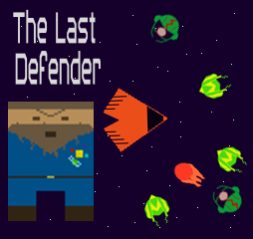

**1. Introduction**

**Inspiration**

**Roboquest (2023)**

Roboquest is a first-person 3D shooter where one faces hordes of enemies with a feeling of unstoppability. Two things stick out to me when playing Roboquest: The music, and the healing system. The music is fast-paced and distinct. Every note is hyping the player up and pressing them forward to an addicting beat. The healing system is fantastic for motivating players to engage with enemies rather than rush past. The only healing during levels is gathered from small orbs dropped after killing enemies.

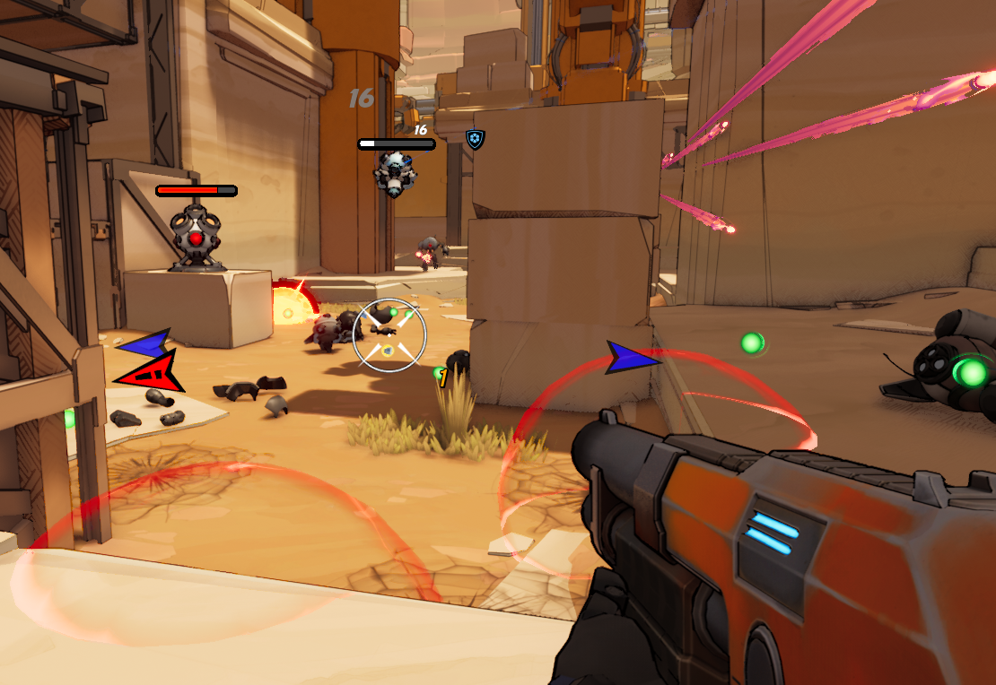

[1]

**Asteroids (1979)**

Asteroids is a top-down 2D shooter where a player navigates a ship shooting asteroids that come across the screen. Shooting asteroids break them up into smaller asteroids until finally, they are small enough to disappear. Though simple, this game is both addicting and fun, and was extremely innovative by being an early arcade game with quick real-time movement and strategy.

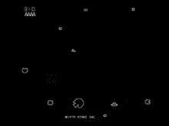

[2]

**Game Summary and Player Experience**

The Last Defender, like asteroids, is a top-down 2D shooter where the player navigates a space with multi-directional movement using forward movement and the ability to turn the ship. The biggest difference is there is no blaster. The player must sacrifice a bit of health to destroy enemies and gather healing ship bits from the debris to heal more than they lost. As their score increases, the game becomes more difficult, allowing more enemies and a higher percentage of the more difficult enemy class to spawn.

**Platform**

This game is built in a WebGL format and is meant to be played in a browser.

**Development Software**

* Unity Version 2022.3.4f1
* FMOD 2.02.25
* rFXGen 4.2 for SFX
* Signal.vercel.app for music creation

**Attributions**

* Music Generation - <https://signal.vercel.app/edit>
* SFX - <https://raylibtech.itch.io/rfxgen>
* Font - [https://www.dafont.com/spaceport-2006.font?l[]=10](https://www.dafont.com/spaceport-2006.font?l%5B%5D=10)
* Space Background - <https://opengameart.org/content/space-background-1>
* FMOD Tutorial - <https://www.youtube.com/watch?v=rcBHIOjZDpk&t=1592s>

**Genre**

Singleplayer, action, fast-paced

**Target Audience**

With a simple game concept and mechanics, this game can be enjoyed by casual game players. Those intending to see how unstoppable they can become can enjoy the never-ending gameplay as the difficulty increases.

**2. Concept**

**Theme Interpretation (You Are The Weapon)**

Part of the fun in a Game Jam is being limited by the theme and seeing how far one can stretch the idea of it to fit the needs of the game. ‘Weapon’ is such a broad term it can fit many clever interpretations within it; but more often than not weapons aren’t clever, they’re simple. Maybe (definitely) it was all the Roboquest I had been playing, but reading the theme, I only took as literally. The player is the near-indestructible, incredibly powerful, defies all logic weapon of mass destruction. I knew I couldn’t make Roboquest in two weeks, but figured I could make something like Asteroids. Just, what if no weapons?

**Player Mechanics**

**Movement**

The movement in this game is very simple. The player can move forward, and change which direction is forward by rotating the player ship either clockwise or counter-clockwise



**Boosting**

The player can boost themselves, giving a sudden jump in velocity which tapers off into a slightly above speed than normal. A small rhythm-based approach is implemented as consecutive well-timed boosts can greatly increase the velocity and maneuverability of the player. Boosting also reduces the damage taken by hitting enemies by half.

**Health**

Health is a heavily managed resource in this game. It slowly goes down, and the only way to get it back up is to destroy an enemy ship and gather the ship-bits. Though each destroyed enemy ship spawns, at minimum, enough ship-bits to heal the damage taken from hitting the ship, the slow health reduction, easily missed ship-bits, and de-spawning of ship-bits after a few seconds create a difficult yet recurring issue of going back for health and potentially wasting time, or moving forward and hoping you do better.

**Controls**

The game is meant to be played on a keyboard and mouse. The controls are limited and specific currently, as a mouse or touchpad is necessary for button pressing in the Main Menu, and the “W”, ”A”, ”D”, and “Left Shift” Keys are hard coded as input indicators.

**Enemies**

To help create that sense of unstoppability, all enemies are destroyed when the player comes into contact with them.

**Basic**

The basic enemy is predictable and dumb. It moves directly to the player at a constant speed and runs into them. This enemy type is heavily prevalent in the beginning, allowing players to get the gist of the game while having access to easily obtainable health.



**Shooter**

The Shooter enemy moves to the player until it reaches a certain distance. It always moves to be within this ring of comfort from the player, and when it is inside, will periodically shoot missiles towards the player. The missiles are not very quick, but as the game progresses and more Shooter enemy types appear, the harder it becomes to avoid the many missiles. Missiles will despawn after a few seconds to avoid the entire screen becoming filled with them.

 

**Future Enemies**

At the time of submission, only two enemy types are included in the game. Two enemies are planned for a future update: Darter and Bomber. The Darter would move quickly in a zig-zag pattern dealing heavy damage, then stop for a few seconds to recuperate giving the player an opportune window to destroy them. The Darter would be a more even match to the players' movement abilities with the boost mechanic. The Bomber would be slow and predictable, exploding into a large expanding field of constant damage to the player. The primary use of the Bomber would be to help avoid the player staying in one area.

**3. Audio**

**Music**

The music is heavily inspired by the soundtrack for Roboquest. Every beat of the fast-paced music drives the player forward to continue their quest and destroy anything in their past. It is fun, exciting, loud, and repetitive. The goal of this music is to achieve that, but with a more synth/retro vibe to fit the pixelated graphics.

**Sound Effects**

The sound effects used throughout this game have two goals. Fit the synth/retro theme, and most importantly give a clear indication to the player that something is happening. rFXGen is incredible for making these quick low-bit sounding effects. The explosions, thuds, blips, chirps, and even grumbles from the captain's dialogue are made with this application, and they are spread throughout the game so that every action the player does has some noise indication to it.

**Future Work**

Ambient music/sound is needed for the title screen, another couple of songs wouldn’t hurt for some variety while the player is endlessly destroying enemy ships. A wider variety of more refined sound effects would be nice. For example, there is no distinct noise if the player pivots, an enemy approaches, or what phase of the boost cycle the player is in.

**4. Art**

**Design**

The artwork is pixelated and simply drawn on a 64x64 pixel square. Though there is no color palette, the use of colors is extremely minimal, with most sprites only having less than three colors.

**Future Work**

A coherent color schema for the enemy ships would be nice, as both enemy types use green as their main color, though the mini-map would need to be changed from simply a wider camera view to one that has indicators for enemy types, rather than their sprite as it is hard to differentiate even now between the two enemy types. A simple color palette would help tie the whole game together as well, as many colors were just picked randomly.